BIZZNOX
HOME PAGE:
- Logo
- Quick links
- Registration & login & forgot password
- Menu
- Main featured category list with small description
- Top 10 current business listed
- Informative video
- Quick feedback button
- Quick links footer
- Social icons & copyright text
Category details page
- Image , description & links to fill forms
- Sidebar with other category navigation
- Each category have 2 options (provider / seeker )
  - Each option to have 2 sub options (Post & browse )
    - Browse :
      - Select State, city (op) and keyword(op) ->search
      - Search listing page with sort by date & filter by price range with pagination & view details
      - Details page : Info entered by user
        - Payment Onetime (payU) with plan type (monthly/ yearly) and expiration

After browse , the system must present the user with uniform and near display of profiles.

The user will browse posting in his chosen category and will express interest to get in touch.
IF he is a paid member - he is entitled to view 5 contact numbers in given month - so he can use that credit and can view the contact number of the person who has posted the ad.

IF he is a free member - the other person (one who has posted the advertisement) will see an expressed interest - and now IF he is a paid member - the he can view the number with the same logic above.

IF both are free members - they won't be able to see each others contacts.
sample express interest window for reference.
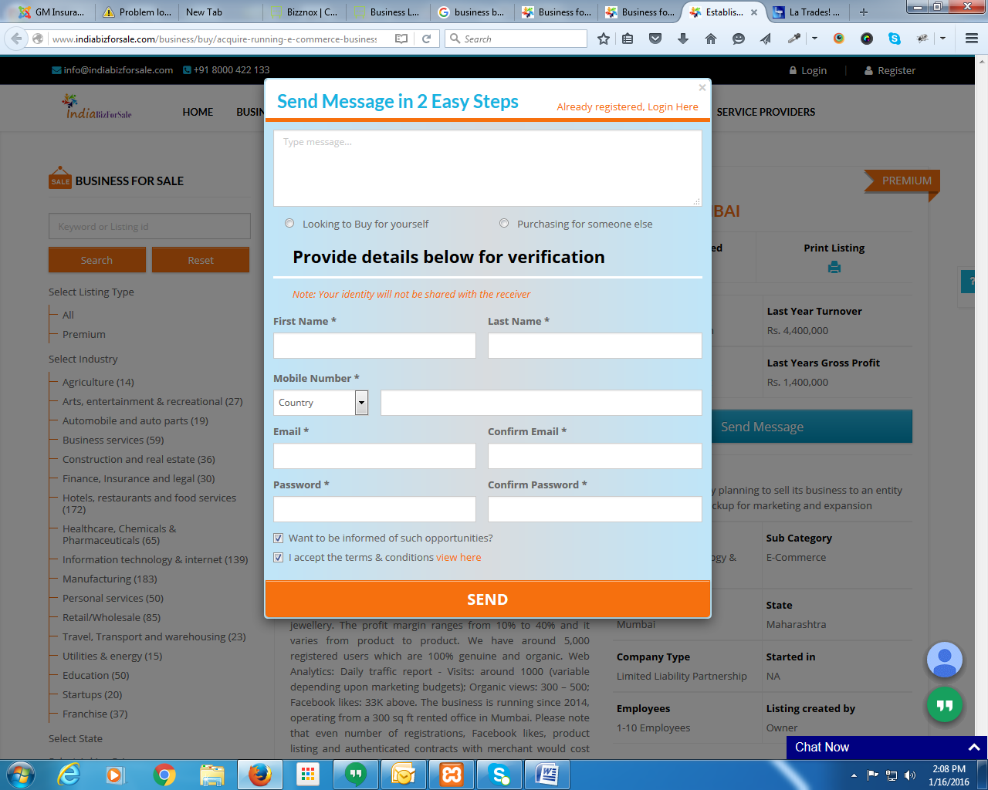
    - Post
      - Unlimited post for free / paid user
      - Form (fields)
        - Name
        - Mobile no
        - Email id
        - Description service with Logo(op)
        - Amount / fees
        - State & city(Multiple)
        - Category (disabled)
        - Upload file
  - My account page
    - Edit Profile
    - Change password / delete account
    - View posted list
    - View express interest list
    - Transaction history
      - List of transaction
      - Download invoice
- Static Pages
- Registration page with email & SMS authentification
- Login with FB & Gmail & LinkedIn
- Weekly email to all registered users for new business listings alerts
- Email Extraction (Gmail / Yahoo) and send joining request with Mailchimp or etc

Admin :
- Category & subcategory mgmt
- Page mgmt
- User mgmt
  - Approve / reject / view details
- Listing mgmt
  - Approve / reject / edit
- Settings
- Business plan Mgmt
- Transaction mgmt

Social Media :
1. USer will be asked to share "Bizznox" banner on their facebook / linkedin / google + or tweeter profile - If they choose to post on all 4, they get 4 months free premium membership. If they choose any one, then they get 1 month premium membership.
http://www.truelancer.com/blog/list-of-100-angel-investors-in-india/

